Performance improvement
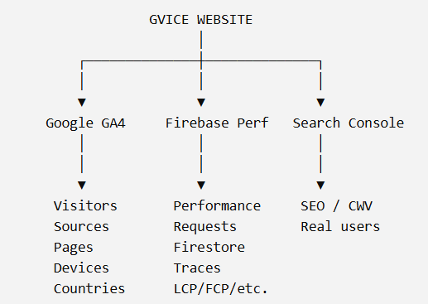

Phase 1 — Baseline
I'll help you capture:
Home
News
Projects
Tenders
Auction
Profile
For each:
Performance score
LCP
INP
CLS
FCP
TTFB
Total JS
Total transferred
Number of requests
Largest resources
Phase 2 — Identify bottlenecks
We'll classify them:
🔴 Critical
🟠 Significant
🟡 Moderate
🟢 Fine
Phase 3 — Optimize
Likely:
Image optimization
↓
Firestore query optimization
↓
Pagination
↓
Code splitting
↓
Lazy loading
↓
Caching
↓
Animation optimization
↓
Bundle optimization
↓
Render optimization
Phase 4 — Add monitoring
GA4
+
Firebase Performance
+
Search Console
Phase 5 — Cookie/consent
Then implement the banner correctly around the actual analytics/tracking stack, rather than adding a meaningless popup.

